Data Audit Report

Prepared by
The Analytics Team

In support of
AnyState Veterans of Foreign Wars

Requested by
VP of Marketing

December 4, 2024

Introduction
The AnyState Veterans of Foreign Wars periodically solicits donations to fund its various initiatives. To improve the effectiveness of their solicitation campaigns, the VP of Marketing has asked your analytics team to build a predictive model and score their marketing database. Their goal is to spend resources more wisely by targeting those most likely to donate.
The first step is to audit the data that will support this model building effort.
The VP of Marketing has provided four (4) datafiles along with a master data dictionary “Data Dictionary – Donor.pdf.” These data files are:
Donor_census – as SAS file of census data linked to a donor identification number (CONTROL_NUMBER)
Donor_profile – a csv file with donor demographic data
Donor_history – a csv file with donor donation history data
Donor_survey – a csv file with responses to a donor survey
Overall, there are data on 19,000+- individuals who had been contacted in a veteran’s donation campaign in 1997. This file has been pre-qualified for us; there is no further qualification required. The target variable is TARGET_B, which breaks the modeling (qualified) sample into two segments: those who gave during the 1997 campaign; and those that did not. We will explore this dataset over the course of this class.

It is the analytics team’s understanding that the target variable segments for this model are:
- Yes/customer has a variable response to 97NK (1).
- No/customer does not have a variable response to 97NK (0).

The purpose of this data audit is to ensure the following:
- The analytics team has received all the data files intended for this project.
- The analytics team understands the content, layout, and format of these files.
- The data in these files are of sufficient integrity and quantity to support the model development.

This data audit consists of 4 sections:

Datafile Summary: A list and description of all data files received.

Datafile Detail: For each datafile, tables showing all data fields received, their values, summary statistics, and distributions. Data fields are categorized into one of 4 types of analytical variables:

Categorical - data fields with distinct levels or values which represent categories; can be a number or a label, nominal or ordinal.

Date - data fields that are identified as calendar dates.

Numeric - data fields that are continuous numeric data.

Character - data fields whose values are characters and are not otherwise classified as categorical.

Modeling Sample – After merging all supplied datafiles, a determination is made as to whether there is adequate sample size for each target sample to support model development.

Questions – The auditing process will uncover data integrity issues. This section lists what the analytics team has found in this regard. This section also poses specific questions on data field definitions, field coding, and interpretation, answers to which will facilitate the team’s model development effort.

Datafile Summary

The analytics team has received 4 data files from VP of Marketing as listed in Table 1.

Table 1. Datafiles Received
Filename | File Type | # Of Records | File Contents
donor_census2 | SAS | 19,372 | CONTROL_NUMBER, WEALTH_ RATING, MEDIAN_ HOME_VALUE, MEDIAN_HOUSEHOLD_INCOME, PCT_OWNER_OCCUPIED, PCT_VIETNAM_VETERANS, PER_CAPITA_INCOME
donor_profile2 | CSV | 19,372 | CONTROL_NUMBER, DONOR_AGE, URBANICITY, SES, CLUSTER_CODE, HOME_OWNER, DONOR_GENDER, INCOME_GROUP, RDCENT_STAR_STATUS
donor_history2 | CSV | 19,372 | TARGET_B, CONTROL_NUMBER, MONTHS_SINCE_ORIGIN, IN_HOUSE, PEP_STAR, RECENCY_STATUS_69NK, FREQUENCY_STATUS_97NK, RECENT_AVG_GIFT_AMT,  RECENT_RESPONSE_COUNT, RECENT_CARD_RESPONSE_COUNT, MONTHS_SINCE_LAST_PROM_RESP, LIFETIME_CARD_PROM, LIFETIME_PROM, LIFETIME_GIFT_AMOUNT, LIFETIME_GIFT_COUNT, LIFETIME_AVG_GIFT_AMT, LIFETIME_GIFT_RANGE, LAST_GIFT_AMT, MONTHS_SINCE_LAST_GIFT, MONTHS_SINCE_FIRST_GIFT
donor_survey2 | CSV | 58,116 | CONTROL_NUMBER, SURVEY_QUESTION, SURVEY_VALUE

Datafile Detail
Each datafile contains the analytic data fields as shown in the following tables. Note that the data fields have been classified based on their potential analytical usage.

Datafile #1: donor_census2
File Analytic Contents:
Numeric Fields (5): MEDIAN_HOME_VALUE, HOME_VALUE,
MEDIAN_HOUSEHOLD_INCOME,
PCT_OWNER_OCCUPIED, PCT_VIETNAM_VETERANS,
PER_CAPITA_INCOME
Categorical Fields (1): WEALTH_RATING
Character Fields (1): CONTROL_NUMBER
Date Fields (0):
Records: 19,372
Columns: 7
Notes: The character data field CONTROL_NUMBER appears to be a row id or index field.

Table 1.1 donor_census2 - Numeric Data
Analytic numeric data fields
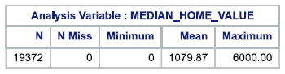 | 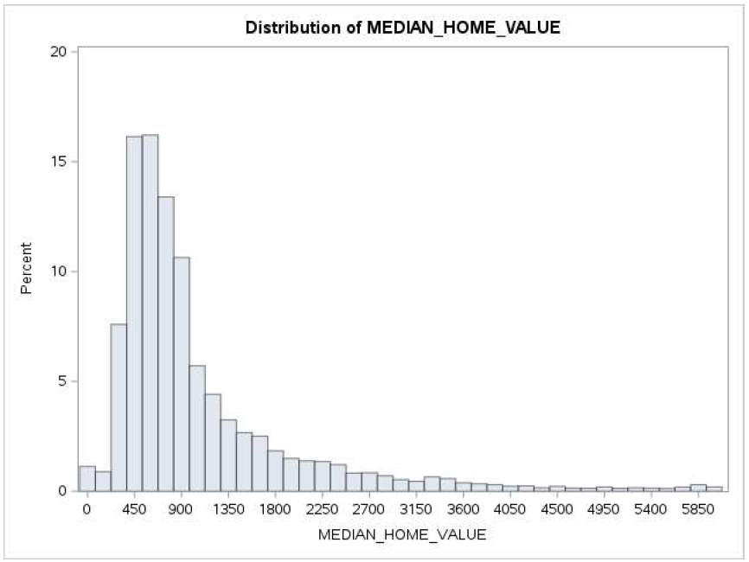
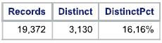
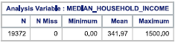 | 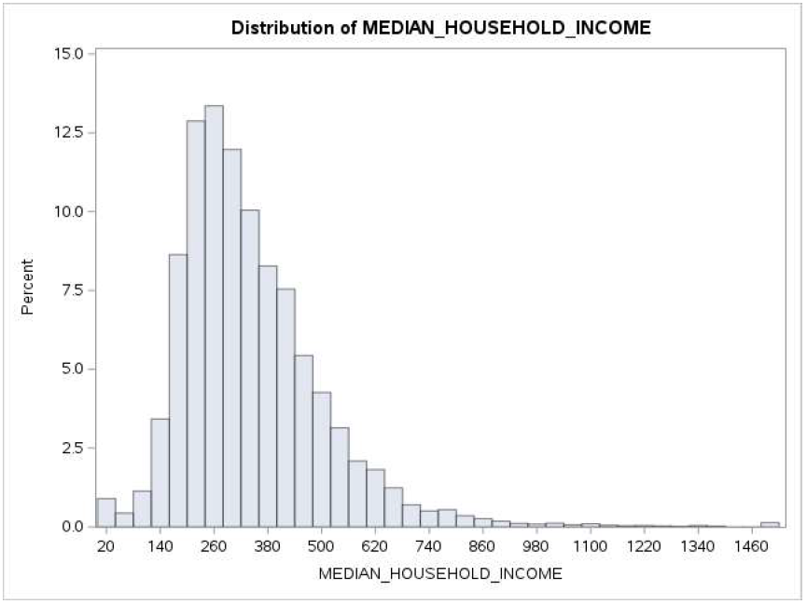
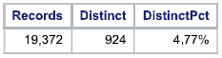

Table 1.1(cont.) donor_census2 - Numeric Data
Analytic numeric data fields
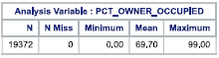 | 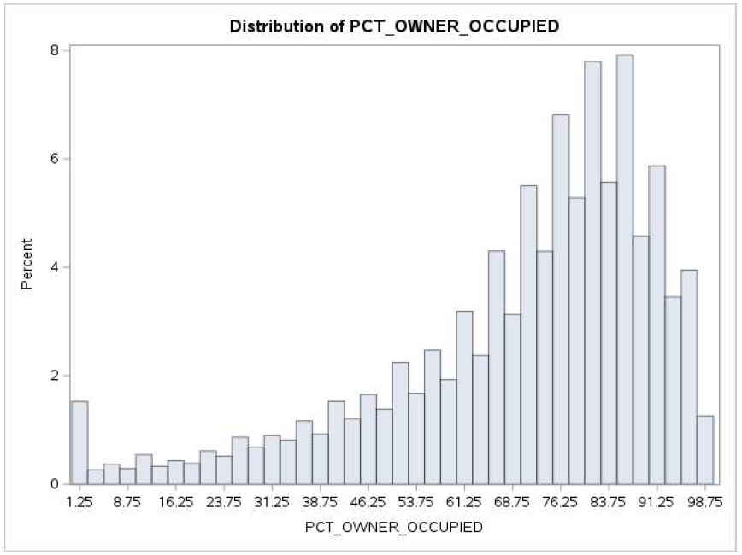
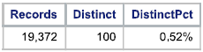
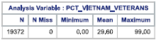 | 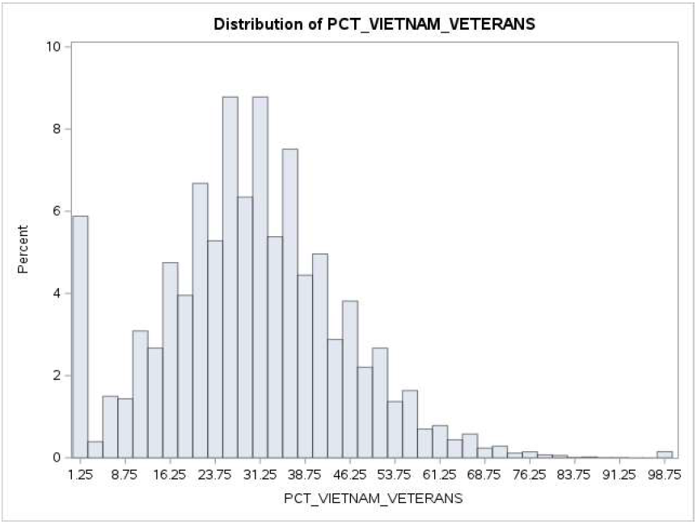
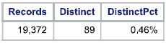
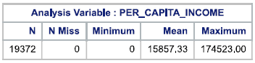 | 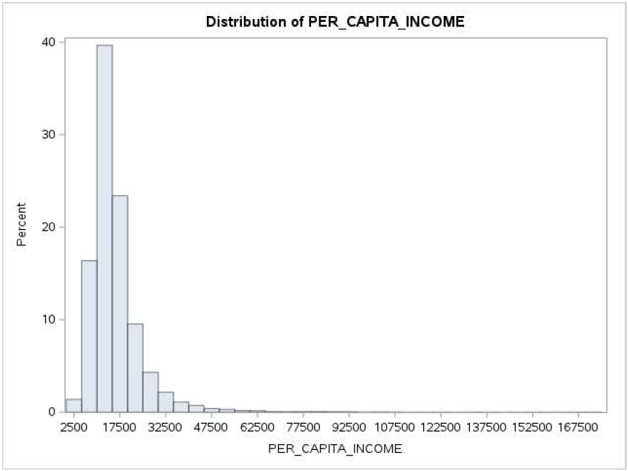
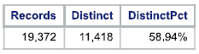

Table 1.2 donor_census2 - Categorical Data
Analytic categorical data fields
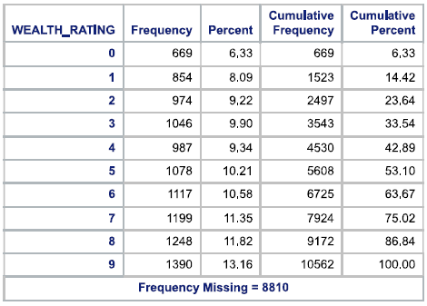 | 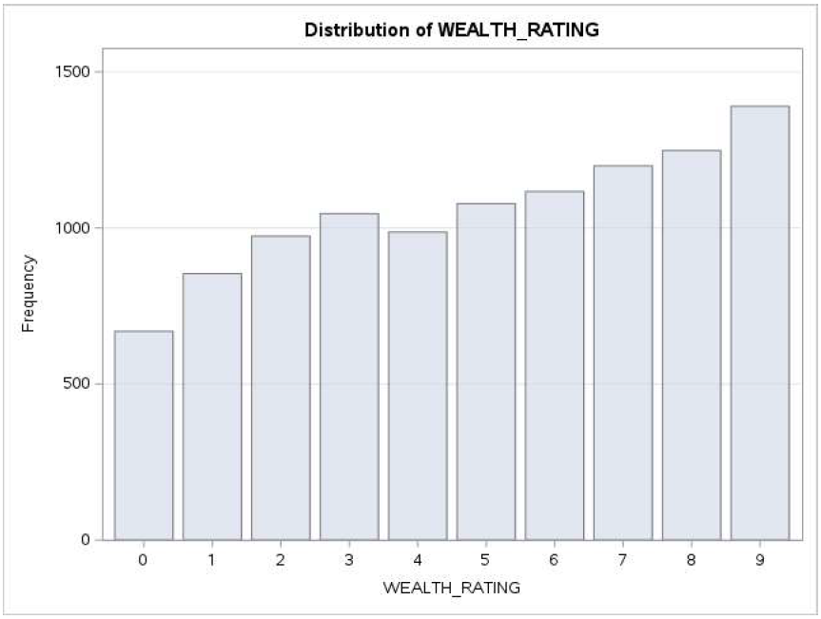
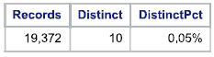

Table 1.3 donor_census2 - Character Data
Analytic character data fields
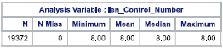 | 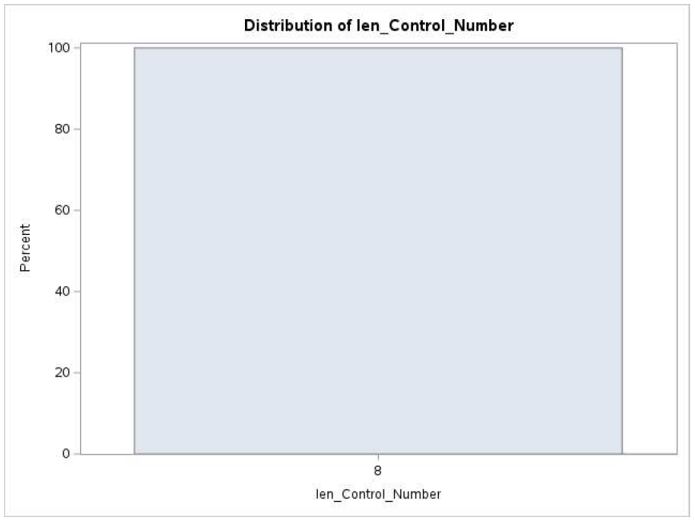
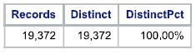

Datafile #2: donor_profile2
File Analytic Contents:
Numeric Fields (2): CONTROL_NUMBER, DONOR_AGE
Categorical Fields (7): URBANICITY, SES, CLUSTER_CODE, HOME_OWNER,
DONOR_GENDER, INCOME_GROUP,
RECENT_STAR_STATUS
Character Fields (0):
Date Fields (0):
Records: 19,372
Columns: 9
Notes: The numeric data field CONTROL_NUMBER appears to be a row id or index field, but will be evaluated as Character Data.

Table 2.1 donor_profile2 - Numeric Data
Analytic numeric data fields
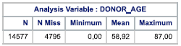 | 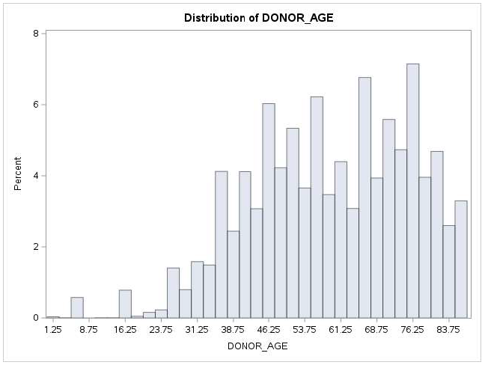
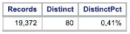

Table 2.2 donor_profile2 - Categorical Data
Analytic categorical data fields
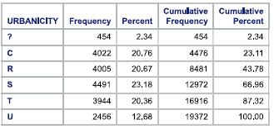 | 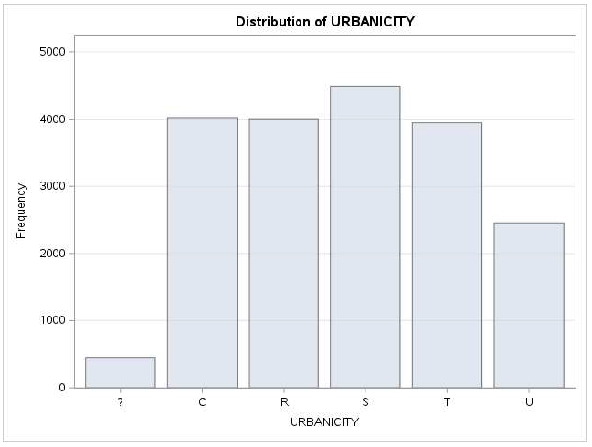
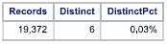

Table 2.2(cont.) donor_profile2 - Categorical Data
Analytic categorical data fields
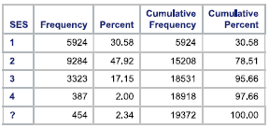 | 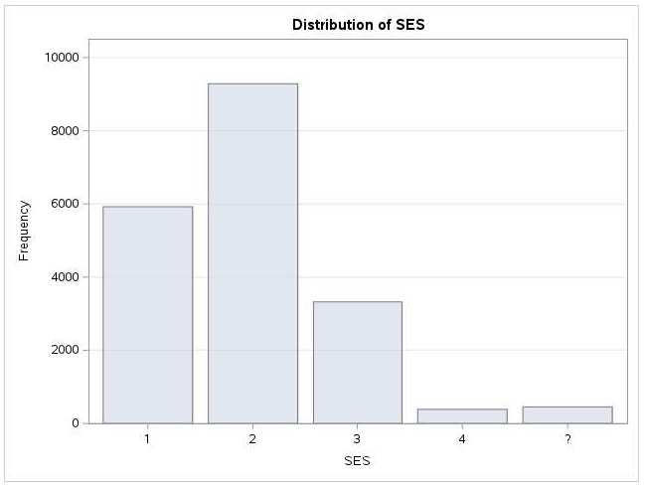
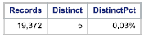
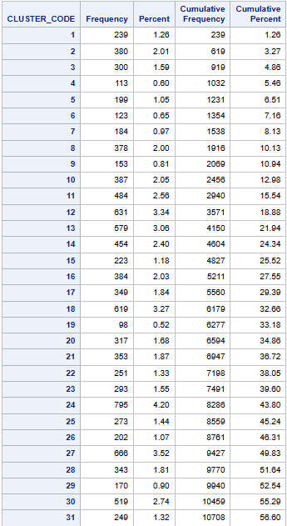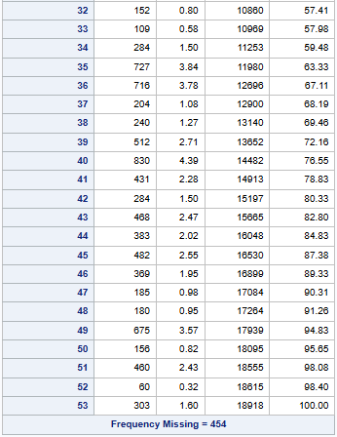 | 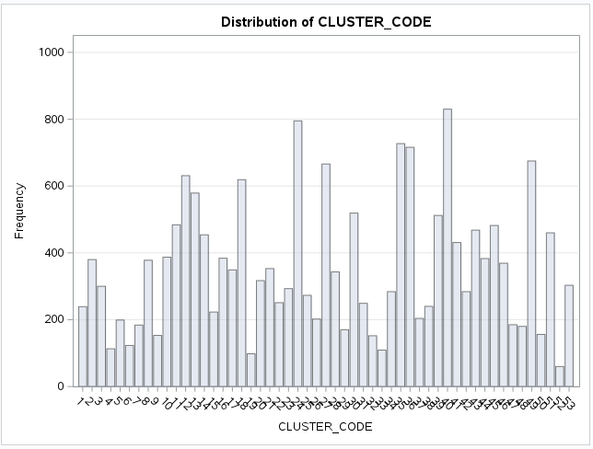  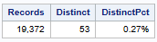
Table 2.2(cont.) donor_profile2 - Categorical Data
Analytic categorical data fields
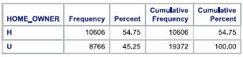 | 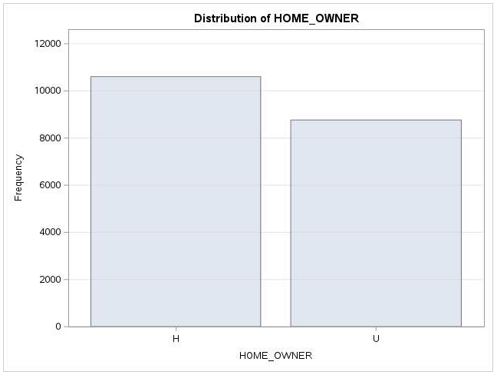
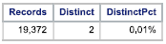
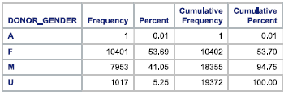 | 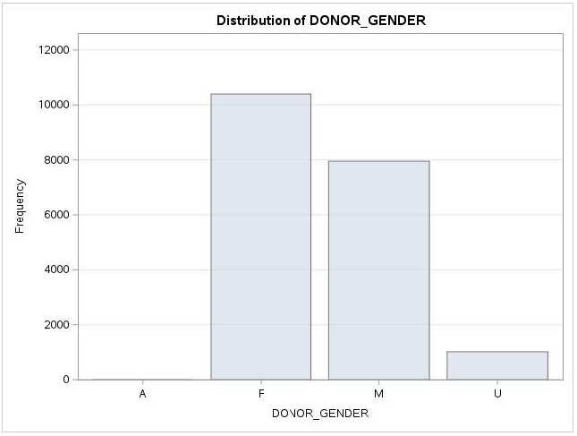
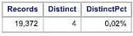

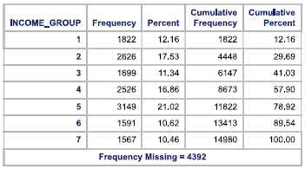 | 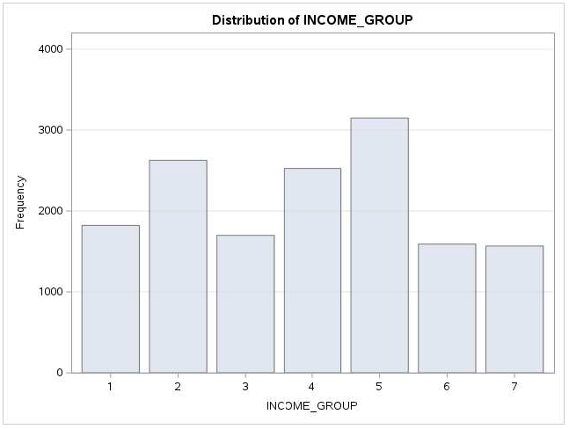
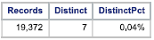

Table 2.2(cont.) donor_profile2 - Categorical Data
Analytic categorical data fields
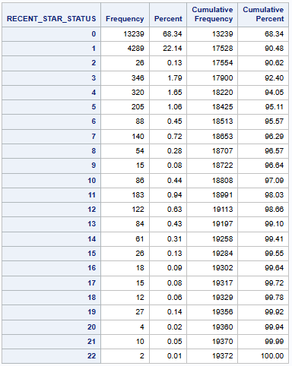 | 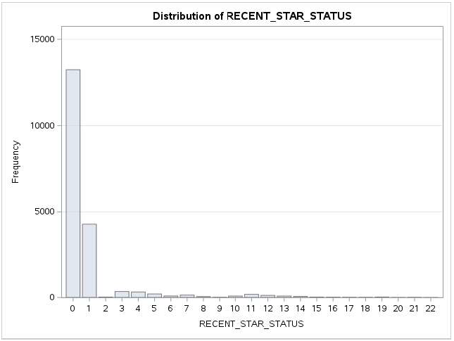
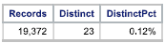

Table 2.3 donor_profile2 - Character Data
Analytic character data fields
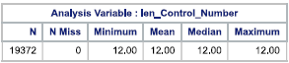 | 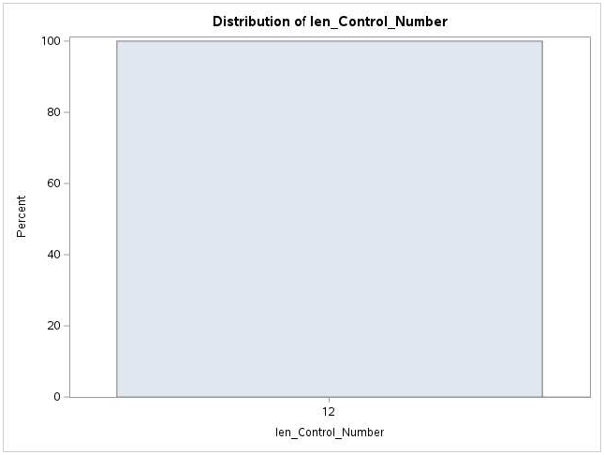
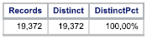

Datafile #3: donor_history2
File Analytic Contents:
Numeric Fields (16): CONTROL_NUMBER, MONTHS_SINCDE_ORIGIN,
FREQUENCY_STATUS_97NK,
RECENT_AVG_GIFT_AMT,
RECENT_RESPONSE_COUNT,
RECENT_CARD_RESPONSE_COUNT
MONTHS_SINCE_LAST_PROM_RESP,
LIFETIME_CARD_PROM, LIFETIME_PROM,
LIFETIME_GIFT_AMOUNT, LIFETIME_GIFT_COUNT,
LIFETIME_AVG_GIFT_AMT, LIFETIME_GIFT_RANGE,
LAST_GIFT_AMT, MONTHS_SINCE_LAST_GIFT,
MONTHS_SINCE_FIRST_GIFT
Categorical Fields (4): TARGET_B, IN_HOUSE, PEP_STAR,
RECENCY_STATUS_96NK
Character Fields (0):
Date Fields (0):
Records: 19,372
Columns: 20
Notes: The numeric data field CONTROL_NUMBER appears to be a row id or index field, but will be evaluated as Character Data.

Table 3.1 donor_history2 - Numeric Data
Analytic numeric data fields
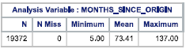 | 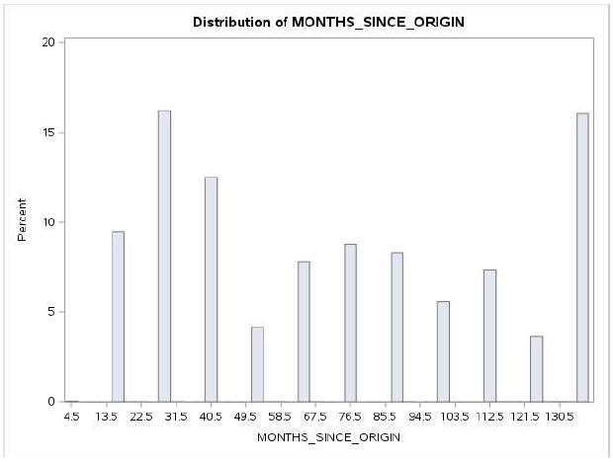
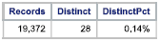
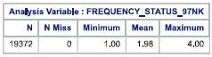 | 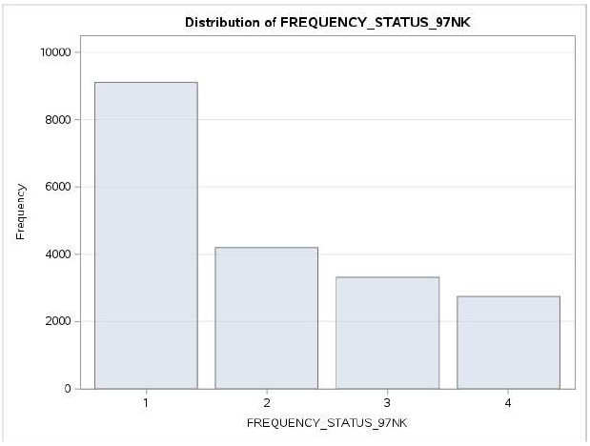
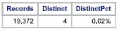

Table 3.1(cont.) donor_history2 - Numeric Data
Analytic numeric data fields
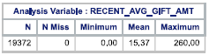 | 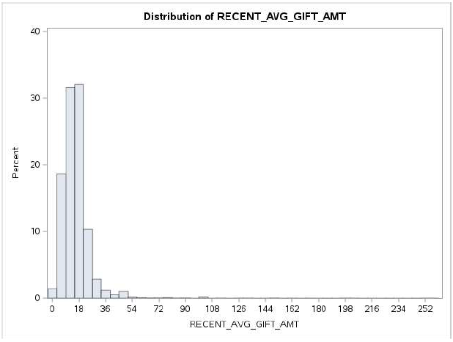
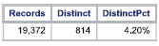
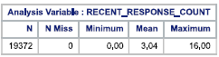 | 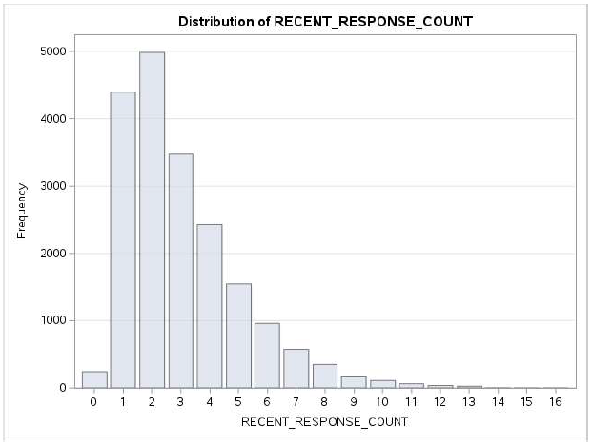
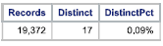
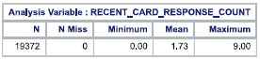 | 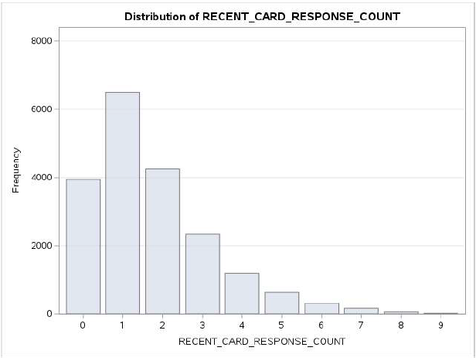
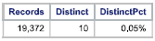

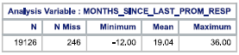 | 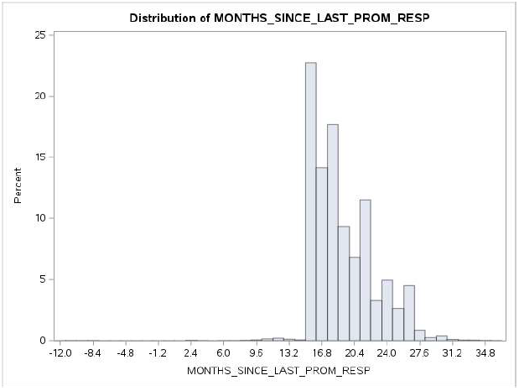
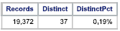

Table 3.1(cont.) donor_history2- Numeric Data
Analytic numeric data fields
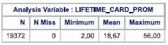 | 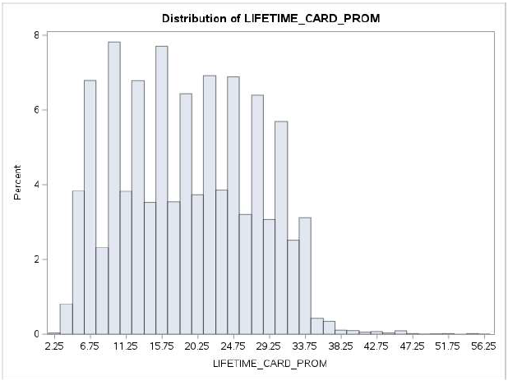
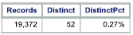
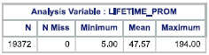 | 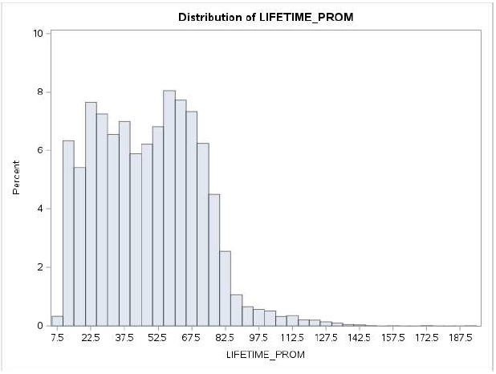
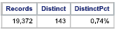
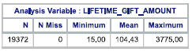 | 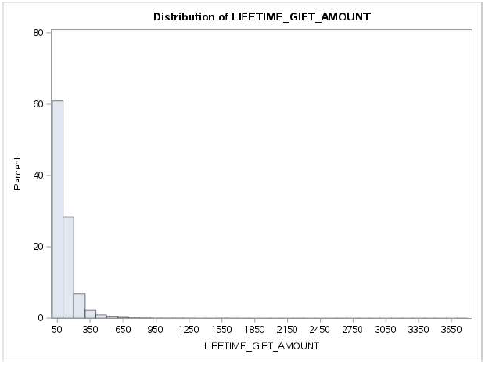
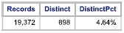

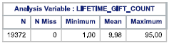 | 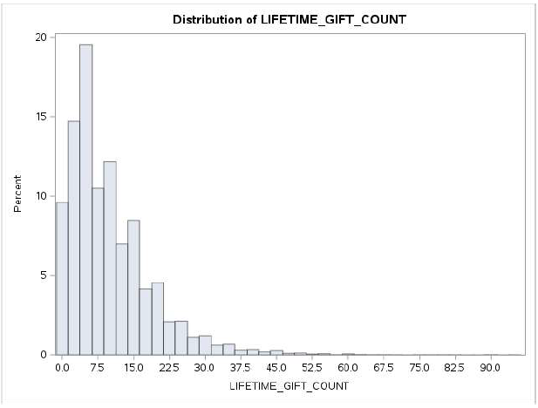
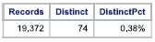

Table 3.1(cont.) donor_history2 - Numeric Data
Analytic numeric data fields
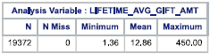 | 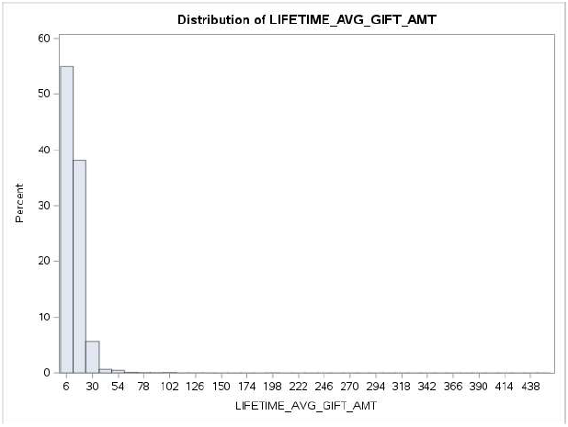
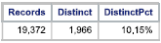
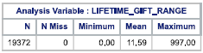 | 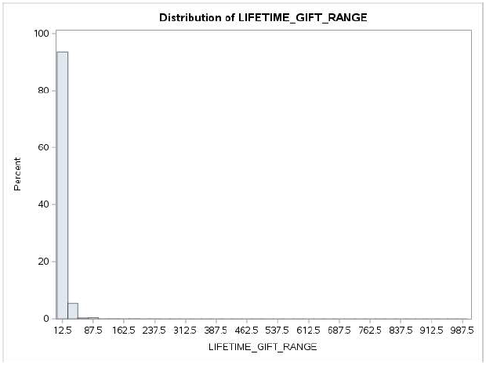
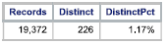
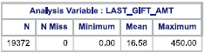 | 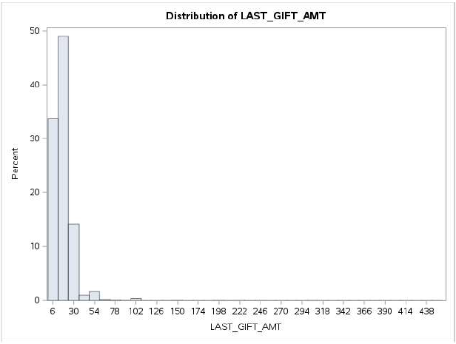
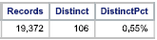

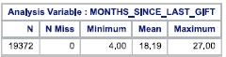 | 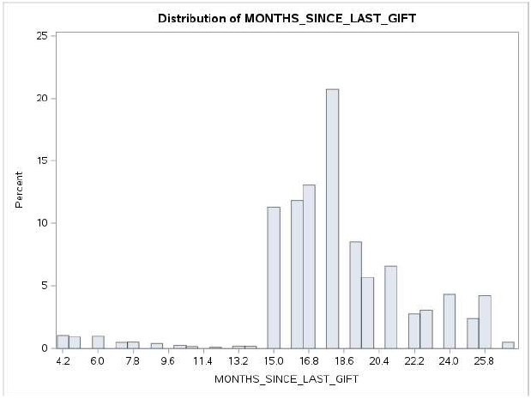
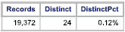

Table 3.1(cont.) donor_history2 - Numeric Data
Analytic numeric data fields
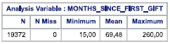 | 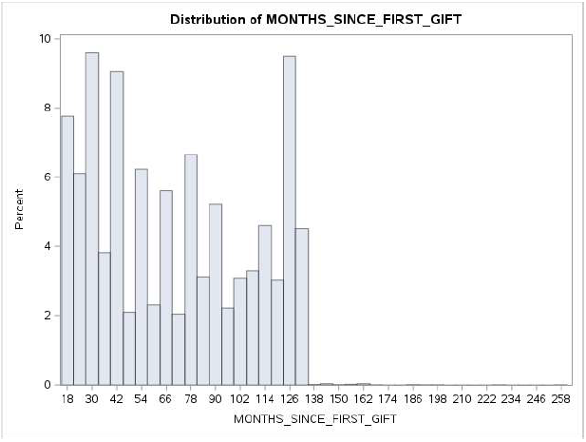
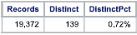

Table 3.2 donor_history2 - Categorical Data
Analytic categorical data fields
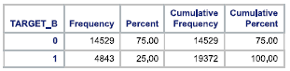 | 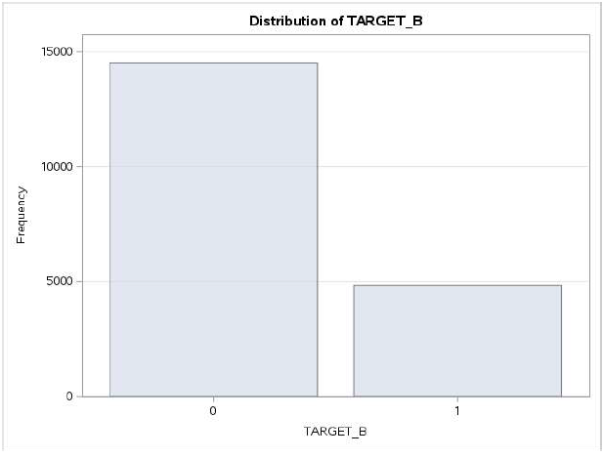
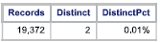
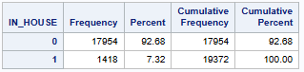 | 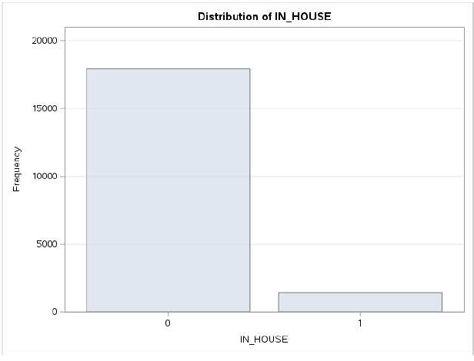
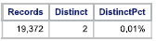

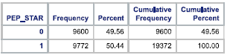 | 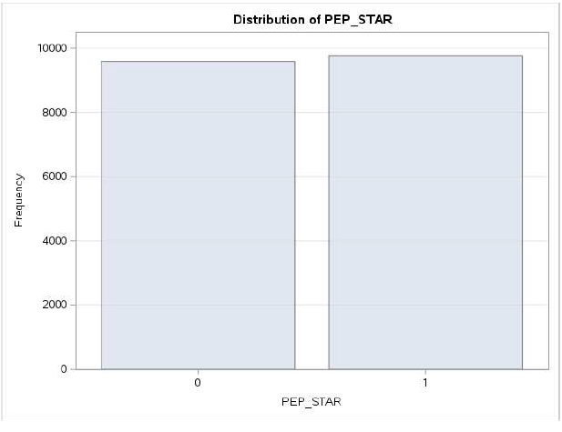
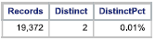

Table 3.2(cont.) donor_history2 - Categorical Data
Analytic categorical data fields
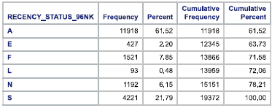 | 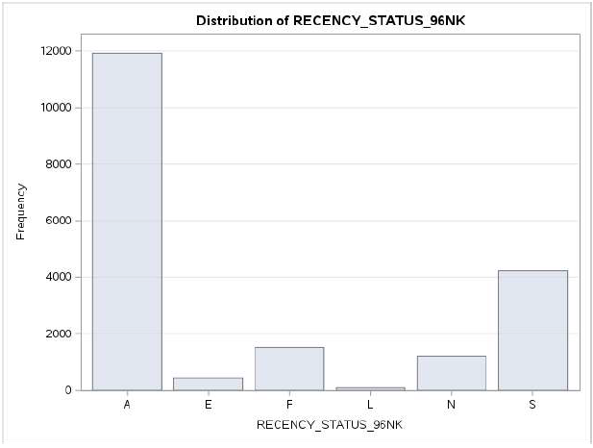
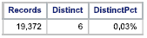

Table 3.3 donor_history2- Character Data
Analytic character data fields
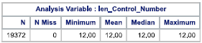 | 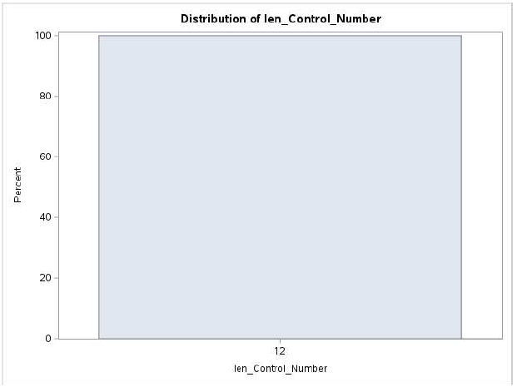
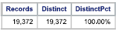

Datafile #4: donor_survey2
File Analytic Contents:
Numeric Fields (2): CONTROL_NUMBER, SURVEY_VALUE
Categorical Fields (1): SURVEY_QUESTION
Character Fields (0):
Date Fields (0):
Records: 58,116
Columns: 3
Notes: The numeric data field CONTROL_NUMBER appears to be a row id or index field, but will be evaluated as Character Data.

Table 4.1 donor_survey2 - Numeric Data
Analytic numeric data fields
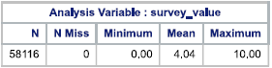 | 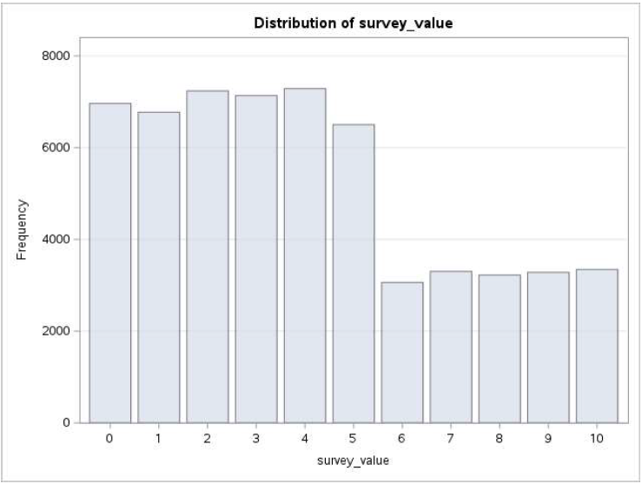
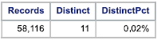

Table 4.2 donor_survey2 - Categorical Data
Analytic categorical data fields
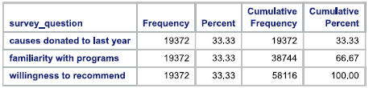 | 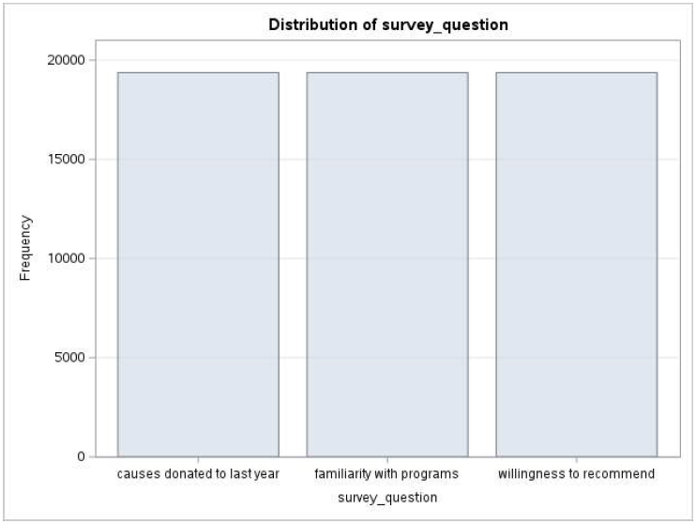
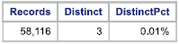

Table 3.3 donor_survey2 - Character Data
Analytic character data fields
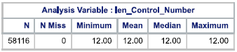 | 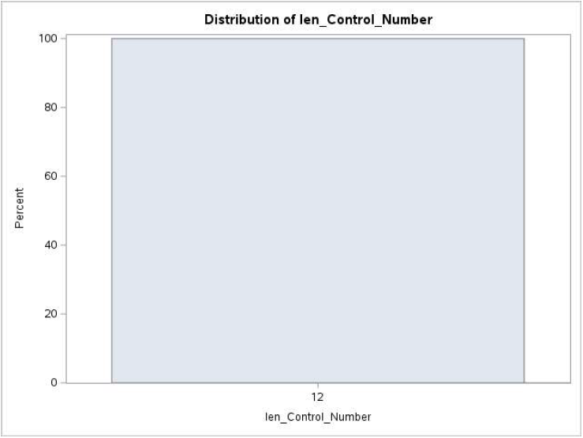
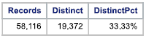

Modeling Sample

Segment | Count
Available event (yes) sample | 7,089
Available non-event (no) sample | 12,283
Total (target) sample | 19,372
Total records in datafile | 19,372

Sample sizes in the target segments appear to be of sufficient/insufficient size to support the predictive model.
Questions

Does the above information appear to be correct? Specifically:

Does the analytics team have all the data that was meant to be sent?

Is the team interpreting the data correctly?

Do the data appear to have reasonable values?

Here is a list of the data integrity issues the analytics team uncovered. Please review:

WEALTH_RATING values were missing in 8,810 cases (45.5%).

DONOR_AGE values were missing in 4,795 cases (24.8%).

URBANICITY has 454 cases with ? value (2.3%). Was this an option? Possibly tied to missing CLUSTER_CODE values.

SES has 454 cases with ? value (2.3%). Was this an option? Most likely tied with missing CLUSTER_CODE values.

CLUSTER_CODE values were missing in 454 cases (2.3%).

DONOR_GENDER had a case with “A” value and 1017 cases with “U” values (5.3%). Are these an option?

INCOME_GROUP values were missing in 4,392 cases (22.7%).

MONTHS_SINCE_LAST_PROM_RESP values were missing in 246 cases (1.3%).

MONTHS_SINCE_LAST_PROM_RESP has a minimum value of -12. Negative values do not make sense for this variable.

The CONTROL_NUMBER ID variable in the donor_census2 file is classified as a character, but is classified as numeric in the other three files.

- The following are specific questions the analytics team has about the data. Please review:

  - What multiplier should be used for the correct value interpretation of MEDIAN_HOME_VALUE and MEDIAN_HOUSEHOLD_INCOME (x100)?
  - What do the URBANICITY values (C,R,S,T,U) mean?
  - What CLUSTER_CODE values are associated with each SES code?
  - What do the HOME_OWNER values (H,U) mean?
  - Is INCOME_GROUP derived MEDIAN_HOUSEHOLD_INCOME and/or PER_CAPITA_INCOME, and what are the 1 to 7 income brackets?
  - What do the RECENCY_STATUS_96NK values (A,E,F,L,N,S) mean?

